Name: Maggie Xu(jx1206), Lia Wang(rw2618), Ziyu Qi(zq2127)
Date:12/20/2024
Section: 001

DMS Project Report - Part IV

Total in points:
Professor's Comments:
Affirmation of my Independent Effort: Maggie Xu(jx1206), Lia Wang(rw2618), Ziyu Qi(zq2127)

Github Repo:
https://github.com/MaggieXxxx/DB-FinalProject.git

Part 4 Documentation:
- Business Use Cases
- Data-Driven Program Module
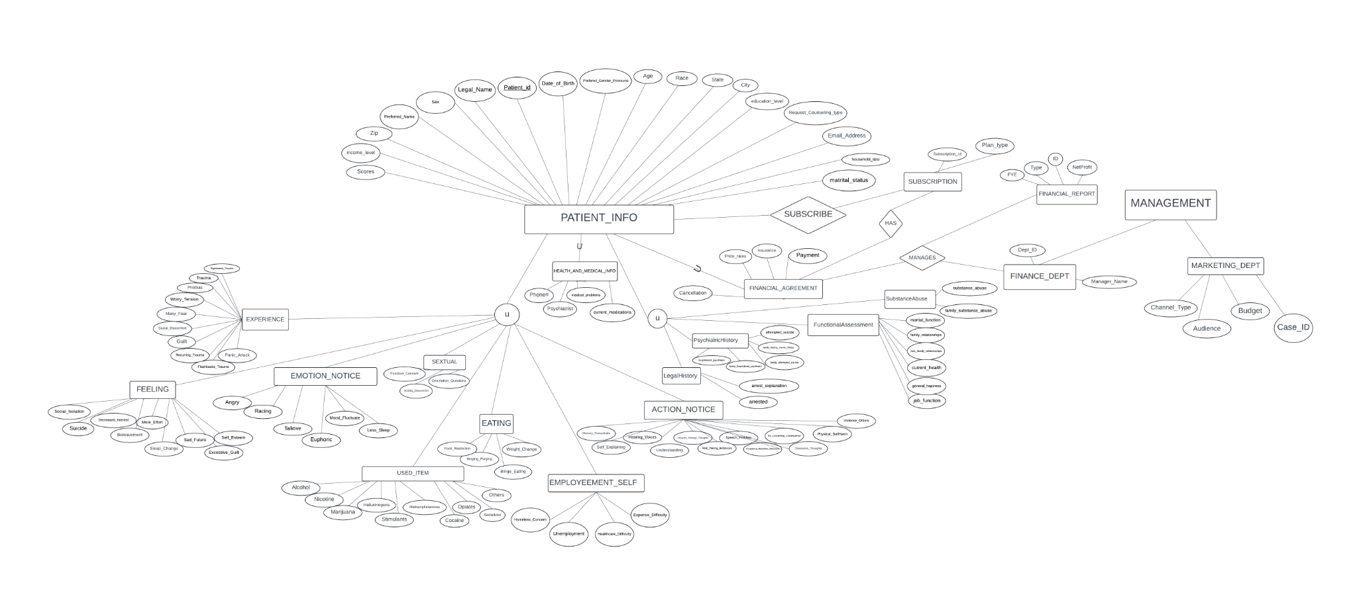
- Database Connectivity and Workflow Integration
- Application and Demonstration
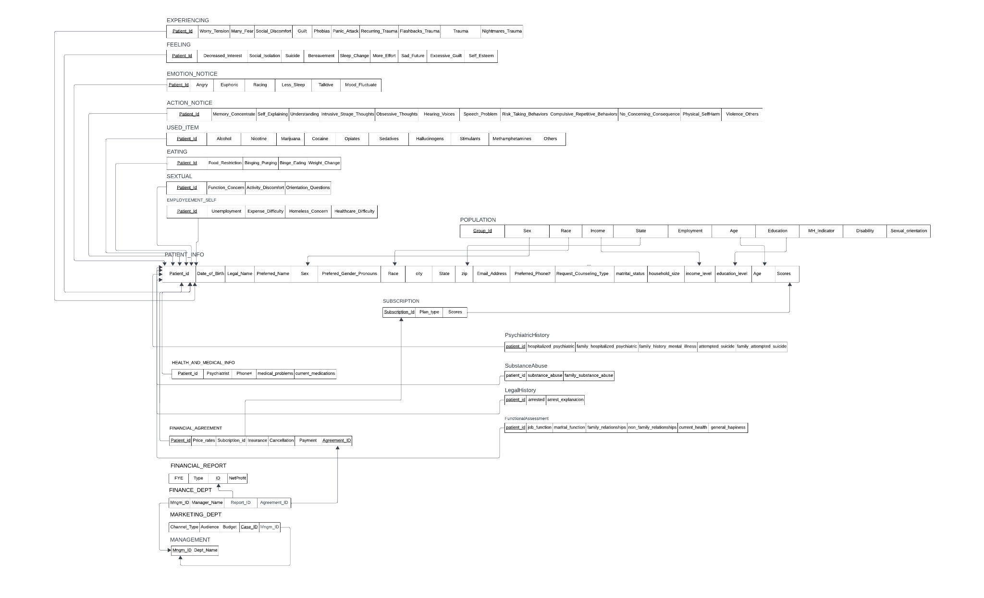

Business Use Case Overview:
- Register/Login: Users input personal and demographic information.
- View Personal Profile: Users can view their stored information, including subscription recommendations.
- Generate Personalized Subscription Plans: The system predicts and suggests a mental health subscription plan based on user-provided data.
- Perform Assessments: Users can answer questions or update information to refine recommendations.
Key Workflow Features:
- Dynamic Updates: Users can update personal details, and recommendations adjust accordingly.
- AI-Driven Predictions: Machine learning models analyze user profiles to generate accurate, tailored subscription recommendations.
- User-Friendly Experience: The system ensures intuitive navigation and data entry with validation checks for accuracy.

User Case Diagram

[User Logs In]
|
|--> [View Profile Details]
| |
| |--> [Update Personal Info] ----> [Changes Saved]
| |
| |--> [Update Preferences] -----> [Changes Saved]
|
|--> [View Subscription Plan]
| |
| |--> [Take Online Assessment]
| | |
| | |--> [Enter Information]
| | | |
| | | |--> [Submit Info to Server] ---> [Server uses machine learning algorithm] ---> [Recommended Plan Displayed]
|
|--> [Submit Subscription]
|
|--> [Make Payment] ----> [Subscription Activated]

Use Case Documentation:
Primary Use Cases:
- User Registration/Login:
  - Actors: End-users
  - Steps:
    - Input name and demographic details (e.g., age, gender, symptoms).
    - Validate and store the data in the database.
    - Redirect the user to the home page upon successful login.
- Generate Subscription Plan:
  - Actors: End-users
  - Steps:
    - Users submit personal details.
    - The system retrieves stored user information and matches it with trained machine learning models.
    - Predicted subscription recommendations are displayed.
- Update Profile Information:
  - Actors: End-users
  - Steps:
    - Users modify personal information (e.g., age, symptoms, or state).
    - System reprocesses updated data and updates recommendations.

Workflow Design:
The workflow uses a data-driven approach, where users interact with a web interface to provide input. A Flask backend processes the input, queries the database, and applies the machine learning model. The model generates subscription recommendations, which are presented to the user in a personalized profile page.

Creation of Data-Driven Program Module
Program Module Implementation:
- Data Loading: The system loads and preprocesses data from a CSV file.
- Machine Learning:
  - Algorithm: RandomForest classifier predicts subscription recommendations based on demographic and behavioral data.
  - Features: Age, gender, symptoms, state, and demographic subgroups.
  - Dummy Variable Scaling: The Value column dynamically scales inputs to align with subgroup importance during prediction.
Prediction Workflow:
- User data is matched to relevant subgroups.
- Features are scaled and input into the model.
- Predictions are mapped to subscription plans (e.g., “Free”, “Premium”).

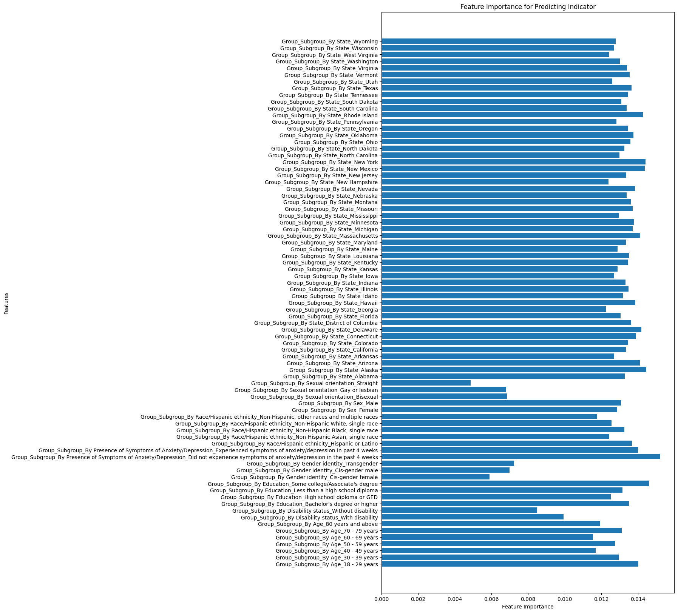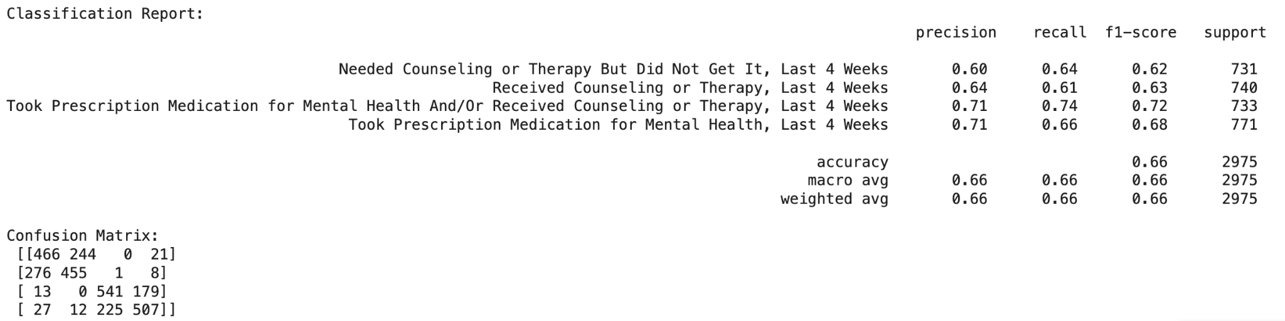

Database Connectivity and Workflow Integration
In this section, the focus is on implementing an end-to-end workflow-based application integrating database connectivity, modular schema design, and a machine learning recommendation system. Using sqlite3 and pandas libraries, this application ensures robust data management and seamless interaction between structured patient information and personalized mental health subscription plans.
The database serves as the backbone of the mental health recommendation system, enabling efficient data storage, retrieval, and manipulation. The implementation integrates foundational relational database management principles with advanced data-driven modules. The primary goals include ensuring referential integrity, scalability, and dynamic adaptability through seamless integration of machine learning recommendations.
Database Setup and Connectivity
- Database Initialization
  - A relational database is created using SQLite, with sqlite3 as the database connectivity framework.
  - The lightweight and flexible SQLite database (mhealth.db) serves as the foundation for data storage and processing.
  - Code snippet for establishing the connection:
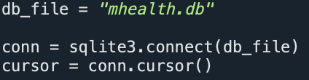
- Schema Design
The database schema is modular, with multiple interconnected tables ensuring separation of concerns and adherence to normalization principles. Each table is designed to ensure referential and entity integrity, with foreign keys linking related entities.
Examples of key tables include(the rest not shown shared a similar structure):
  - PATIENT_INFO: Stores demographic and basic patient details.
  - HEALTH_AND_MEDICAL_INFO: Extends patient information with medical history.
  - SUBSCRIPTION: Tracks subscription plans and associated data.
Example Code for PATIENT_INFO Table Creation:
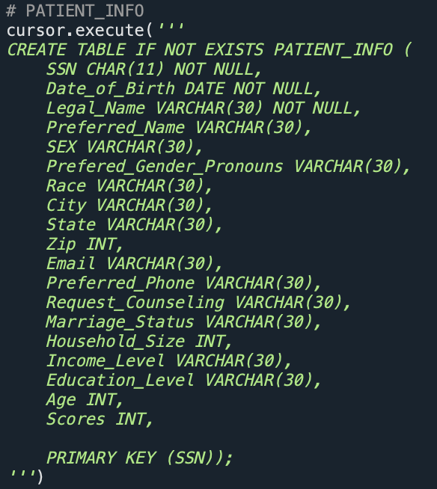

Data Workflow Implementation
Preprocessing ensures that raw data aligns with the database schema before ingestion. The pandas library is employed to standardize column names and structure incoming data.
- Data Ingestion and Preprocessing
  - pandas is used to load and preprocess data from CSV files.
  - Column names are standardized to align with database schema
The workflow leverages a Flask backend for API-based data submission and updates. Dynamic updates ensure that user profile changes propagate across related entities in real time. The integration of AJAX facilitates asynchronous communication between the frontend and backend, enhancing responsiveness and user experience.
- Relational Integrity
  - Referential integrity is enforced via foreign keys, ensuring consistent relationships between tables.
  - For example, the HEALTH_AND_MEDICAL_INFO table uses SSN as a foreign key to link with PATIENT_INFO.
- Dynamic Updates
  - User profile updates trigger database modifications, reflecting changes in real-time across related tables.

Integration with Machine Learning
The machine learning module employs a RandomForest classifier to generate personalized mental health subscription recommendations. The model, trained on demographic and behavioral data, is serialized and dynamically invoked during user interactions.
Prediction Workflow：
- User inputs are collected and preprocessed via the web interface.
- The processed data is fed into the RandomForest model to generate recommendations.
- Predicted subscription plans are displayed to the user and stored in the SUBSCRIPTION table.
Code Snippet — Flask API for Recommendations：
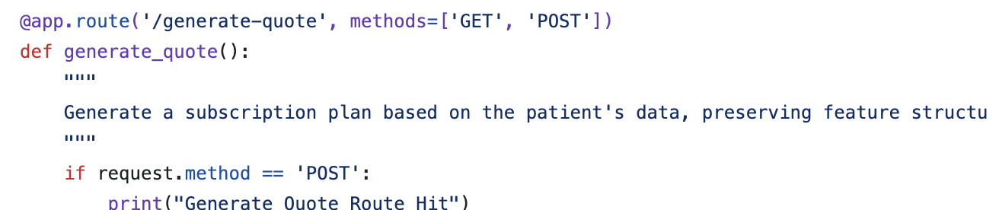

Application Workflow:
- User register or log into the system.
- Answer questionnaires based on personal information.
- A personalized profile is generated
- Answer the Symptom Assessment Form
- Displaying results and recommendations.
- Updates to demographic or behavioral data trigger dynamic recalculation of predictions.
This database workflow demonstrates a robust integration of relational database principles, machine learning algorithms, and dynamic user interaction. By leveraging SQLite for structured data storage and Flask for workflow orchestration, the system ensures scalability and adaptability. The incorporation of optimization strategies and security protocols further underscores its potential for real-world applications in personalized mental health management systems.

Application & Demonstration
The application is designed as an end-to-end solution to generate personalized subscription plans. It automates the workflow from collecting user demographic data via a web login interface, processing it using a machine learning model, storing data in the database, and presenting recommendations and brief profiles to the end-user. The solution integrates OLTP operations for real-time data handling and ODS for reporting and analytics.

Based on the above workflow and business use, we designed the application for our business as following:
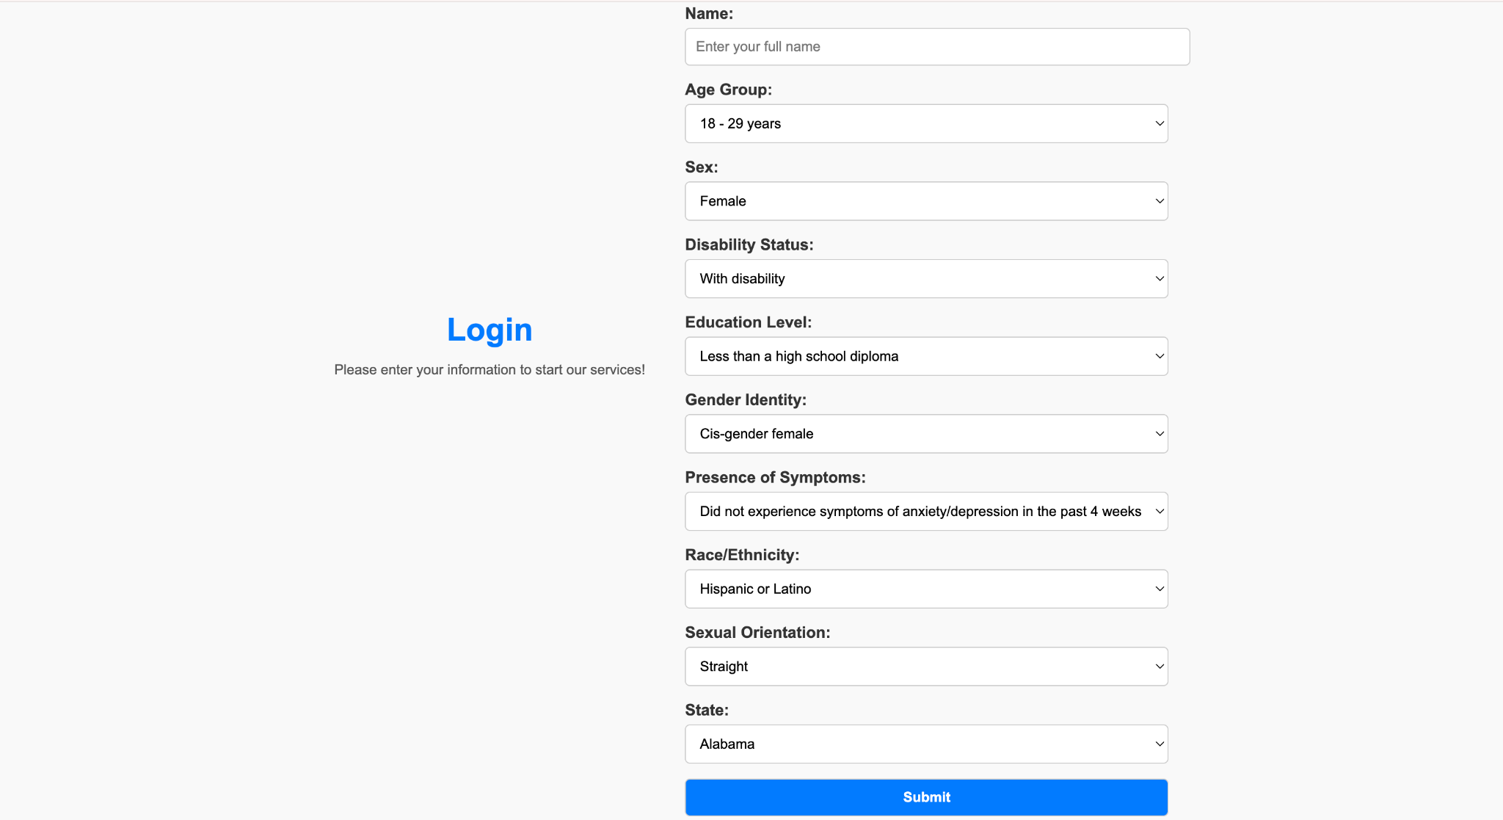
- After navigating to the correct website, users will first come to the login page. On this page, users are required to enter their personal information, including full names, age groups, sex, disability status, education level, gender identity, presence of symptoms, race/ethnicity, sextual orientation, and residence state. On the users end, they will be able to navigate into the website by entering this information, while at the same time, we are able to collect the client's personal data for further processing and modeling on the website back end.
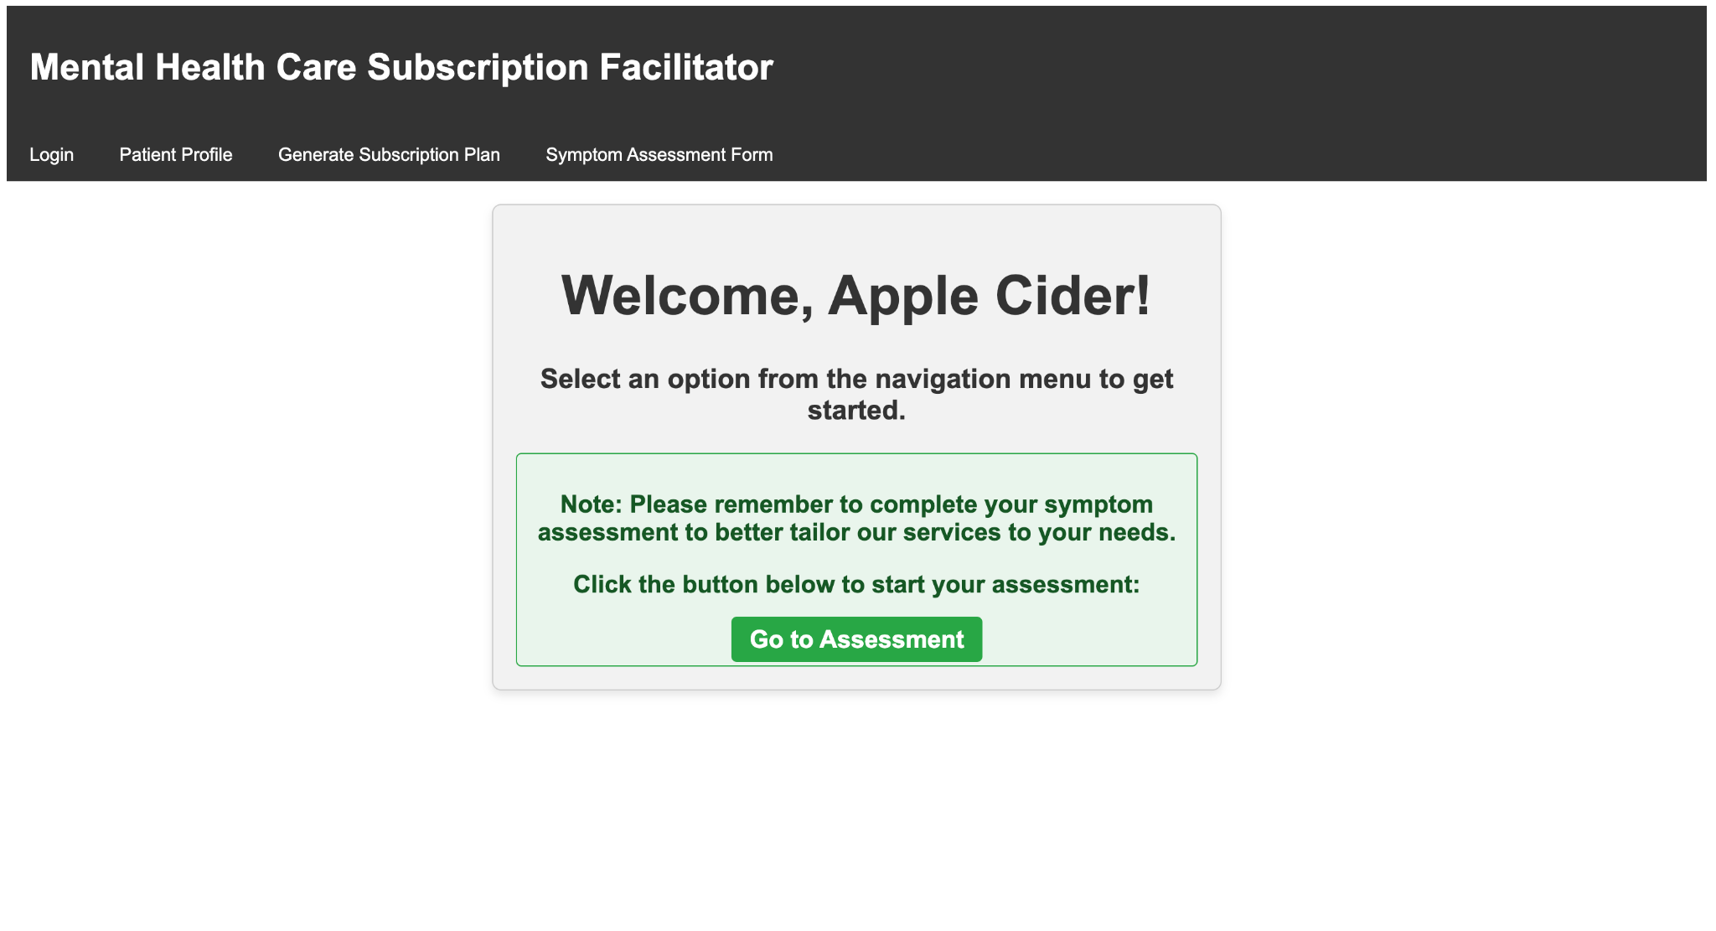
- After correctly login, users will come to this home page, where they will see some welcome message with their names on (e.g. Apple Cider). They will also see some tabs on the top of the home page that can lead them to the other pages. But to better tailor users’ data with our service plan, we designed a reminder box under the welcome message and a button “Go to Assessment” to direct them to the symptom assessment form. We design this specific order of web page visits for users to give better guidance on the user end on our website and allow us to collect users’ data more quickly on the website back end.
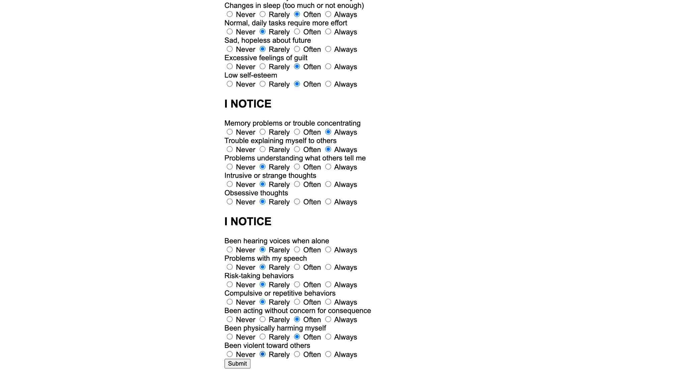
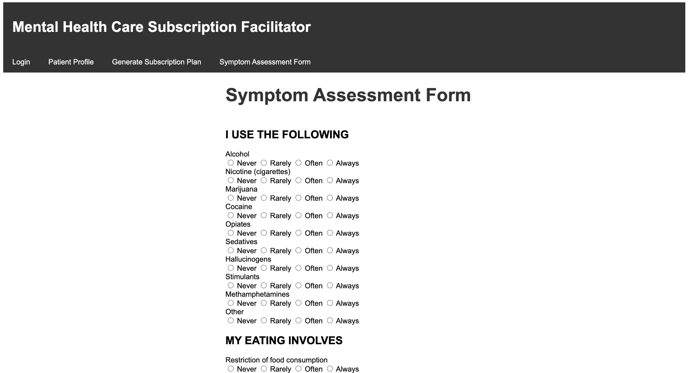

- After users click the “Go to Assessment” button, they will be directed to this Symptom Assessment Form page. By going through this page, users will do 8 sections of questions that test on their existing symptoms and how severe their conditions are. To make the result reliable for further modeling, all questions on this page are set to be “required”. If users do not finish the assessment, they cannot submit this form successfully.
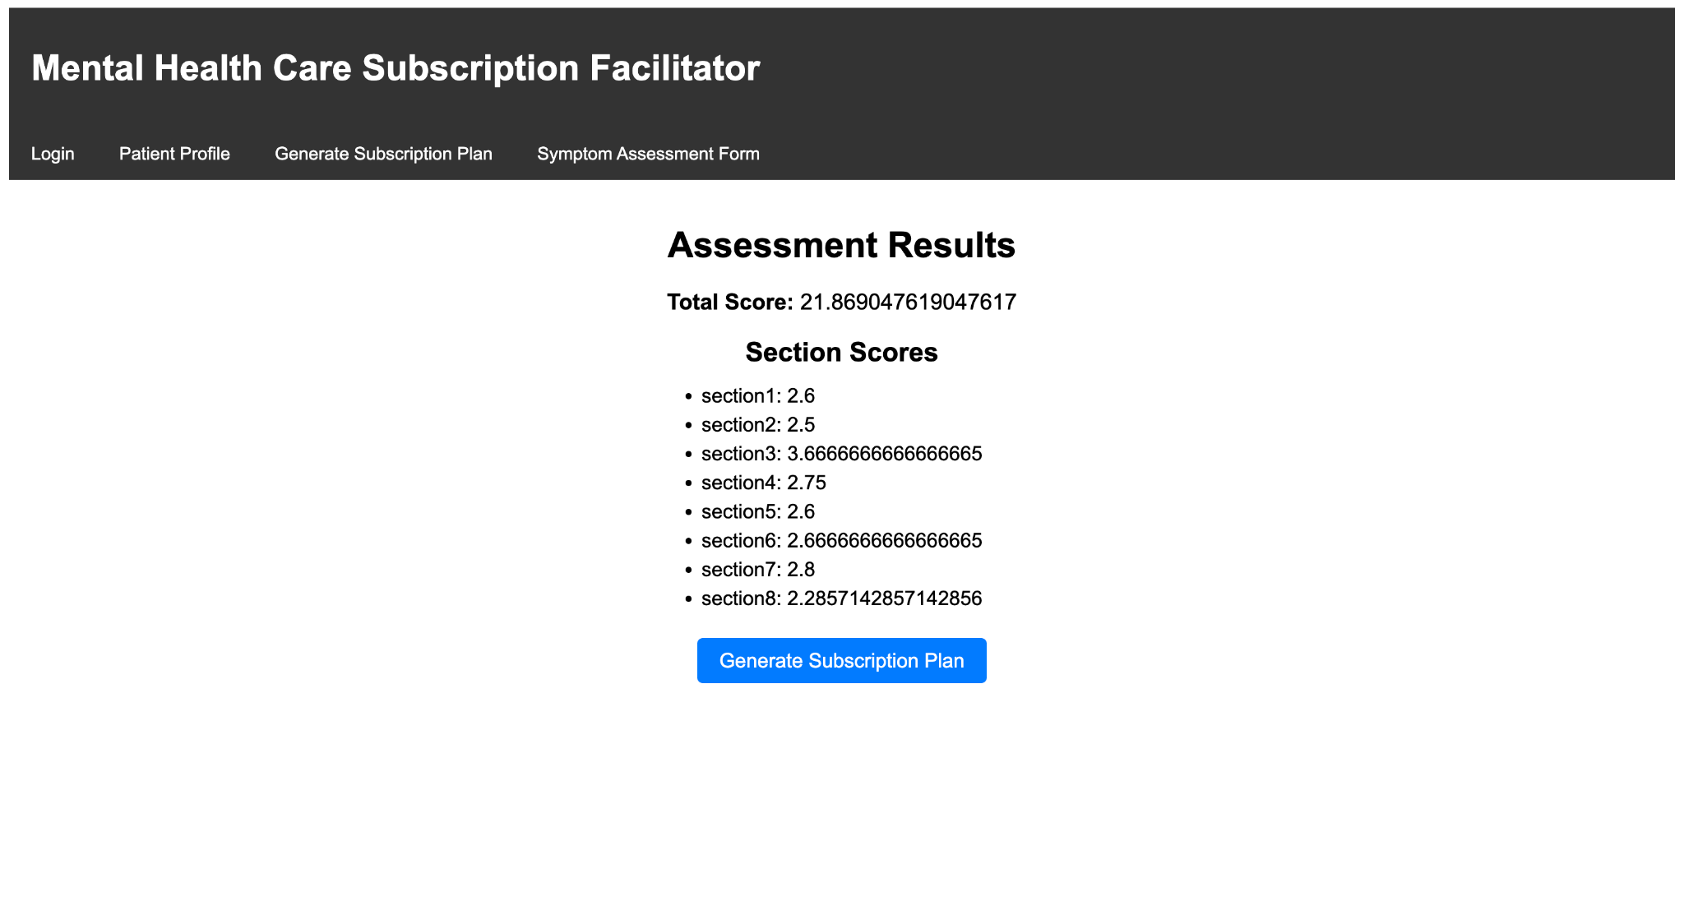
- After users submit their assessment form successfully, they will be directed to the result page, where they can see their total score of the assessment and the average score of each section. The total score is the sum of the average score from each action. After we collect their score data, we can start to generate the suitable subscription service plan for users with all their data. By our end, we will do this by the model we insert inside the webpage back end. On the users end, they will be able to complete this process by click the “Generate Subscription Plan” button on this page.

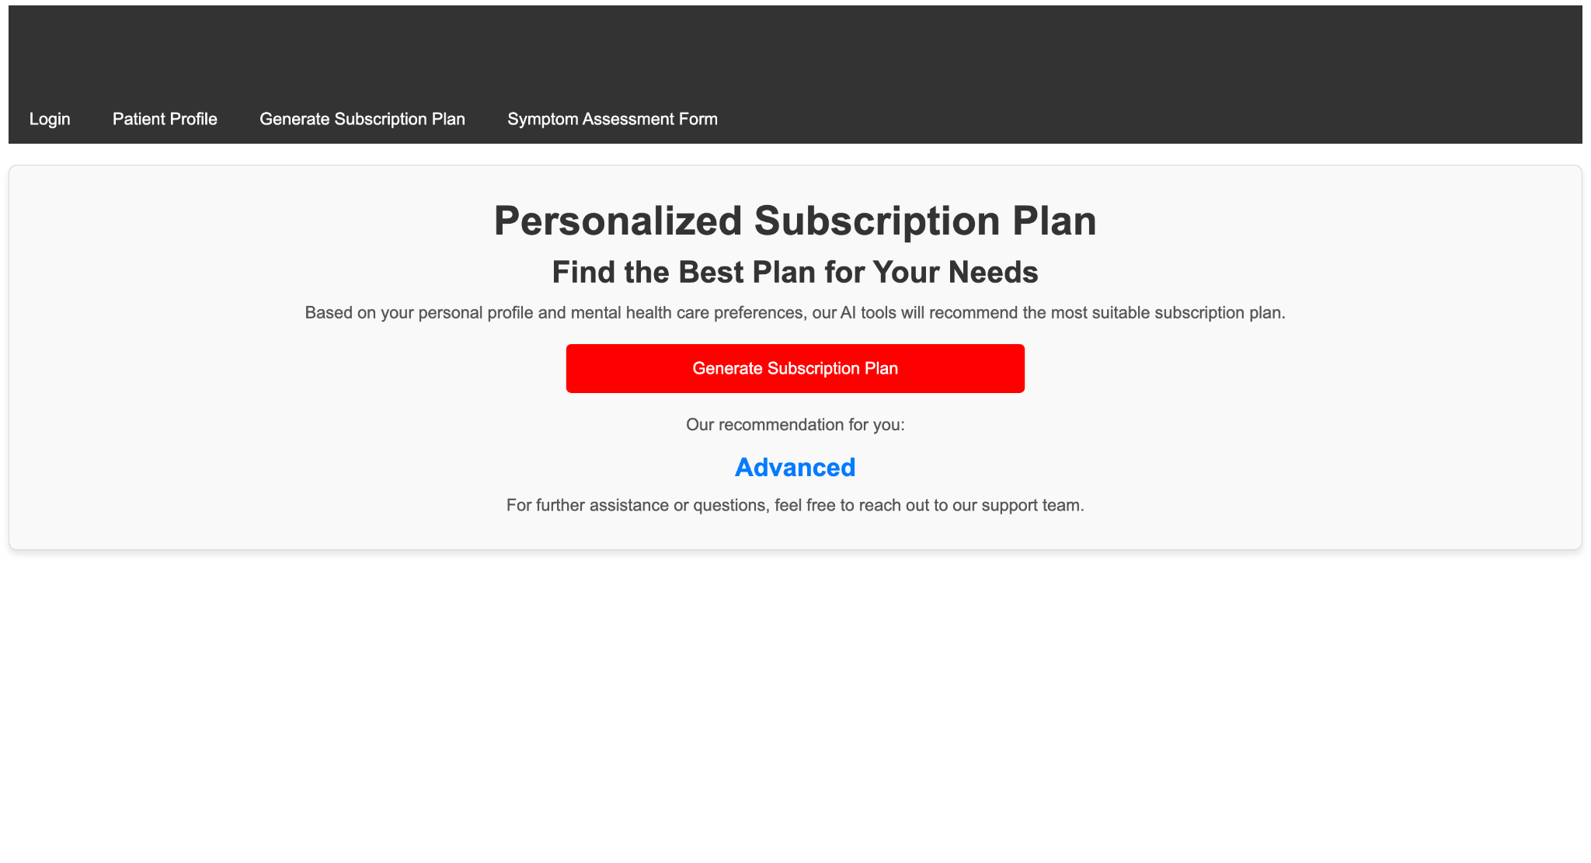

- After users were navigated to the generating subscription page, we designed some messages to tell the users that the plan shown later will be the best plan based on their needs and entered data. On the user end, they can click the red “Generate Subscription Plan” button to output their recommended plan. On the website back end, all things are done by our pre-trained model and output the results for the users.
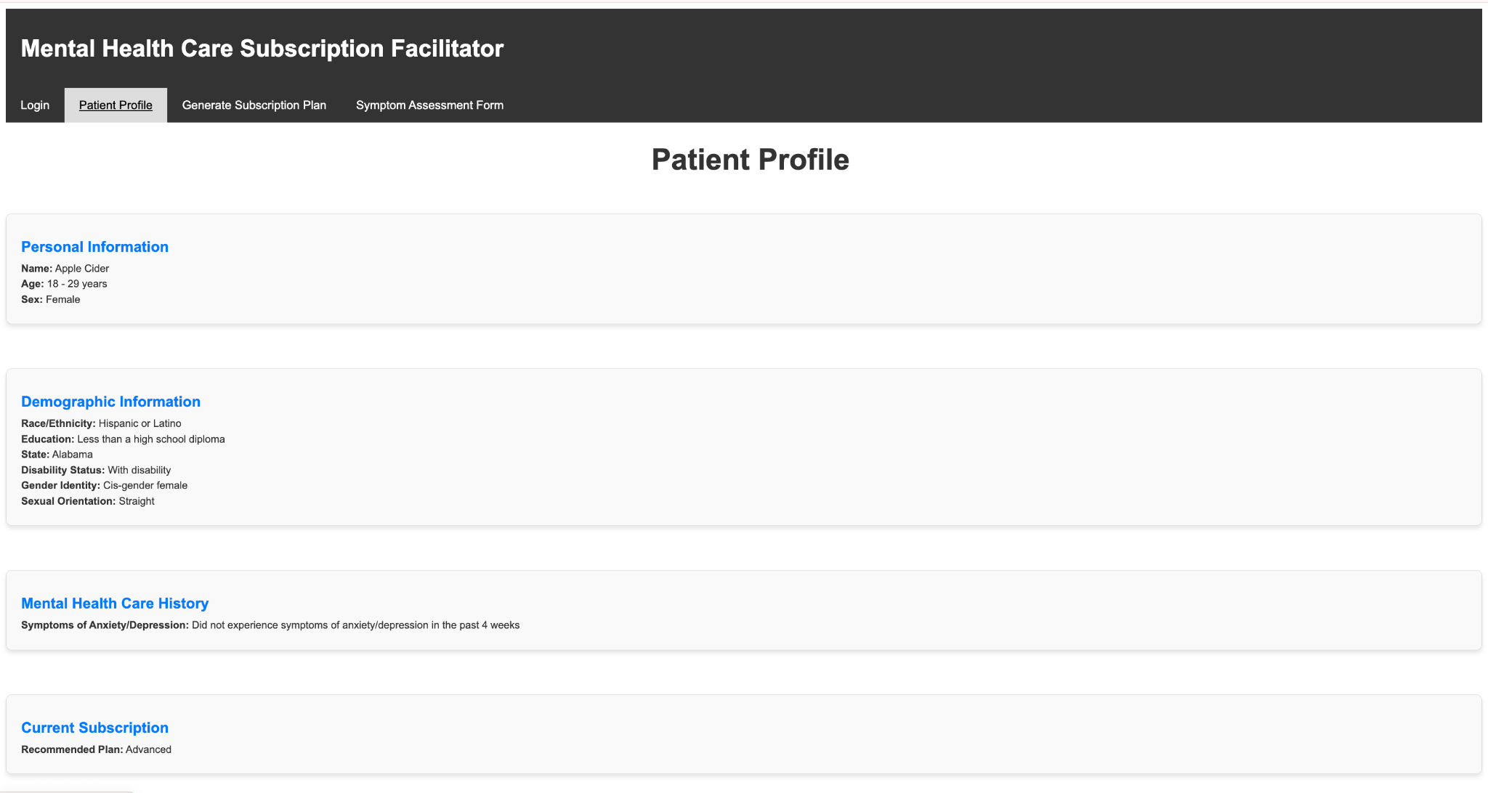
- If users want to check out their profile later, they can navigate to the Patient Profile page by the tab on the top of each page. On this profile page, they can see all their personal information and the current subscription plan we previously generated. This is done by storing the collected data in the database on our end and retrieving the data from the database when users navigate to this page.

The application integrates the gathering of data-driven insights by leveraging a machine learning model trained on the demographic information from the external dataset. When users provide their input through the web interface, the data is processed and passed to the machine learning module, which generates personalized recommended subscription plans in real time. These insights and newly entered user data are then stored in the OLTP database, ensuring they are immediately available for operational purposes, such as displaying results or user profile to the end-users on the platform. This integration ensures that the system supports both real-time interactions and providing operational insights, allowing end-users to benefit from timely and accurate recommendations while us as administrators can monitor the user profile for further analysis.

To optimize the database queries in our application, several techniques were implemented to ensure efficiency and scalability. For example, query optimization was achieved by creating indexes on frequently queried columns, which significantly reduced query execution time for read operations. Additionally, large tables are divided into several smaller tables to reduce the complexity of data retrieval.These optimizations collectively ensured the database could handle real-time user interactions while supporting analytical processes with minimal latency.

End-to-End Reference Architecture (RA) Documentation
This section finalizes the end-to-end Reference Architecture (RA) for the mental health management system, emphasizing its integration across business, application, pyramid of knowledge (DIKW), and infrastructure domains. The vision of this RA is to serve as the foundation for delivering personalized mental health recommendations aligned with enterprise goals of operational excellence and user-centric service. This architecture provides a unified framework that integrates data-driven insights, machine learning models, and dynamic user interactions while ensuring scalability, transparency, and fairness.The RA within this project is built upon the following core principles:
- Alignment with Business Goals: Ensure all IT solutions support the strategic goals of the mental health service platform
- Scalability: The architecture supports increasing data volume, user base, and complexity of insights without compromising performance.
- Interoperability: Ensures seamless integration across diverse data types (structured and unstructured) and platforms.
- Modularity: Facilitates independent development, testing, and deployment of components for enhanced maintainability.
- Standards-Based Design: Adopt industry standards to ensure compatibility and maintainability.
- Proactive Reuse: Facilitate reuse of components to reduce duplication and improve efficiency.
- Transparency and Fairness: Mitigates biases in machine learning models, ensuring ethical and equitable decision-making.
- Data Governance: Implements strict policies to maintain data quality, prevent data losses, and safeguard user privacy.
Organizing Framework
The RA is structured into the following four domains:
- Business Domain
  - Objective: to align the architecture with enterprise goals to deliver value through personalized mental health services.
  - Key Components:
    - User registration and login functionality.
    - Personalized symptom assessment workflows.
    - Dynamic updates to user profiles and recommendations.
  - Outcome: Enhanced user engagement and improved service delivery through actionable insights.
- Application Domain
  - Objective:Enable dynamic and real-time interaction between users and the backend system.
  - Key Components:
    - Frontend: A web interface for registration, questionnaire completion, and result visualization.
    - Backend:A Flask-based API for managing database queries, user sessions, and machine learning predictions.
    - Dynamic Updates to User Data: The architecture now incorporates a transaction-safe workflow to handle dynamic updates to user profiles, ensuring that every modification is validated and persisted reliably.
  - Workflow: (shown in Application Workflow)
    - Users register or log in.
    - They complete questionnaires based on personal and behavioral information.
    - A personalized profile is generated and displayed.
    - Users complete the Symptom Assessment Form, triggering backend calculations.
    - Recommendations are dynamically updated and presented to the user.
  - Outcome: Ensures responsiveness and accuracy in delivering recommendations.
- Pyramid of Knowledge (DIKW)
  - Objective: Transform raw data into actionable insights using the DIKW framework.
  - Key Components:
    - Data: User demographic and behavioral data stored in relational databases.
    - Information: Structured organization of data via schema design.
    - Knowledge: Insights generated by machine learning models (e.g., RandomForest for subscription predictions).
    - Wisdom: High-level recommendations tailored to user needs, enabling informed decision-making.
  - Outcome: A structured process for deriving actionable insights, ensuring effective decision support.
- Information:
  - Data Layers: Transactional data stores capturing user demographics, behavioral inputs, and recommendations.
  - Data Flow: Ensures seamless integration of raw input data into machine learning pipelines for actionable insights.
- Infrastructure Domain
  - Objective: Provide a reliable and scalable foundation for data storage, processing, and analysis.
  - Key Components:
    - Database: SQLite for structured data storage.
    - Data Processing: Integration of pandas for preprocessing and Flask for API routing.
    - Deployment: Cloud hosting for accessibility and scalability.
  - Outcome: Ensures system reliability, performance, and accessibility.
  - Database Update Mechanism:
    - SQL UPDATE statements integrated with transaction management ensure consistency during data updates.

Comprehensive Methods
Plan:
- Define workflows for key use cases, including registration, symptom assessment, and recommendation delivery.
- Develop data flow diagrams to map interactions between users, the database, and the machine learning model.
Deliver:
- Utilize agile development to iteratively integrate database schemas, machine learning models, and frontend interfaces.
- Test individual components (e.g., data ingestion, API endpoints) before integration.
Operate:
- Implement automated logging for monitoring API and database performance.
- Periodically retrain machine learning models using updated user data to improve accuracy.

The development of the Reference Architecture (RA) for our mental health recommendation system was guided by a comprehensive methodology that ensures effective planning, delivery, and operational support. During the planning phase, our team engaged with relevant stakeholders to align the system's objectives with enterprise goals. The iterative design process ensured that workflows, including the user registration, questionnaire completion, and symptom assessment, were thoroughly tested and refined to meet functional and user experience requirements. We leveraged agile methodologies during the delivery phase, allowing for incremental integration of core components, such as the relational database, Flask-based backend, and Random Forest machine learning model. This approach facilitated the seamless addition of new features, including dynamic updates to user profiles and real-time recalculations of recommendations. In the operation phase, we implemented automated monitoring mechanisms to track the performance of database queries and prediction workflows. Additionally, our team planned to design procedures for periodically retraining the machine learning model to incorporate new data, ensuring that the system remains adaptive to evolving user needs. These methods collectively ensure the scalability, reliability, and robustness of the system.

Overarching Governance
Governance is a cornerstone of the Reference Architecture, ensuring that the system operates with transparency, security, and fairness while achieving enterprise objectives. Governance mechanisms are critical for ensuring the integrity, security, and fairness of the Reference Architecture. Data quality is maintained by standardizing and validating input data formats during the ingestion process, which prevents inconsistencies and ensures that all user data conforms to the required schema. This rigorous preprocessing guarantees that the data used by the system is accurate and reliable. To address data security, sensitive information such as Social Security Numbers (SSNs) and user responses from scoring tests access is restricted exclusively to authorized personnel. These measures safeguard user privacy and prevent unauthorized access to confidential data.
In terms of lifecycle management, clear policies are defined for data retention and deletion to comply with ethical and legal standards. These policies ensure that outdated or irrelevant data is removed systematically, reducing risks associated with data misuse or privacy breaches. Transaction management is a key component, ensuring that updates to user data are atomic—either fully completed or entirely rolled back in the event of an error. This prevents partial updates and guarantees the consistency of user records, even under concurrent access. To uphold fairness, bias mitigation processes are implemented, including regular audits of the machine learning model (e.g., Random Forest). These audits help identify and correct biases, ensuring equitable outcomes for all user groups and promoting ethical decision-making within the system.
Finally, transparency is a cornerstone of governance. The system provides detailed documentation and visualizations of the machine learning model’s predictions, enabling end users and stakeholders to understand the rationale behind personalized recommendations. This transparency fosters trust in the system, ensuring that users feel confident in the fairness and accuracy of the recommendations they receive.

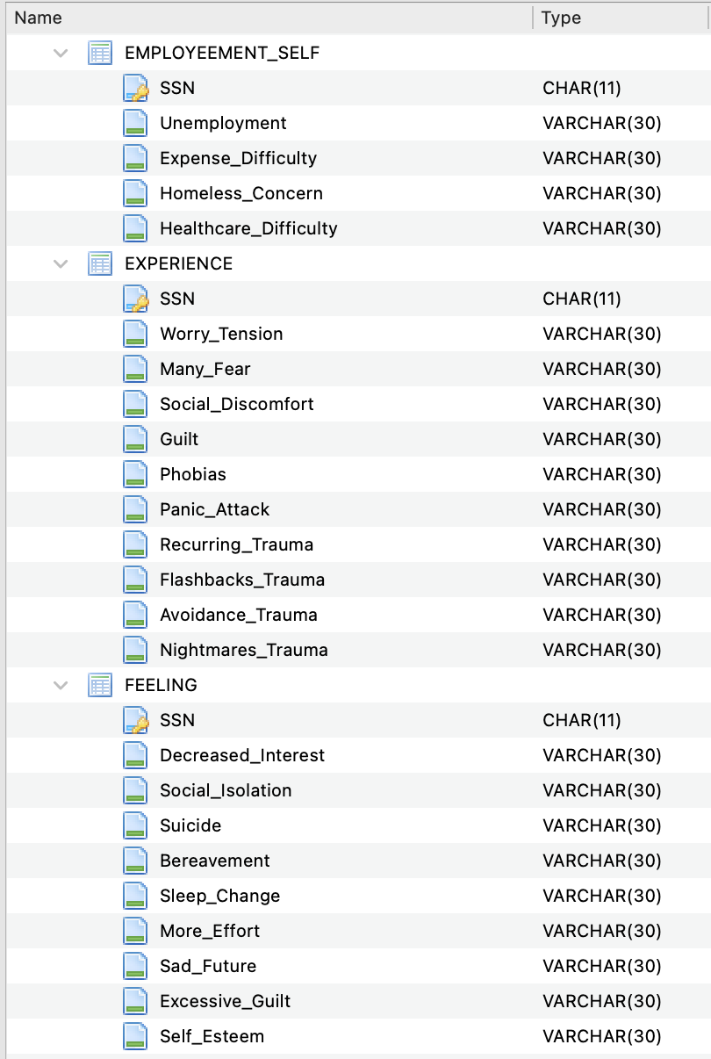
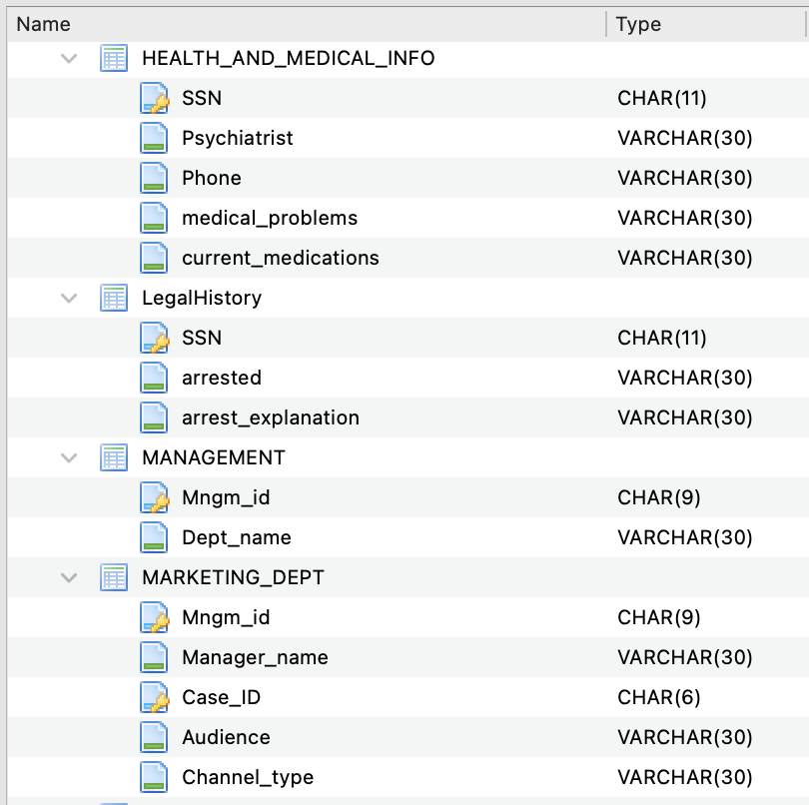
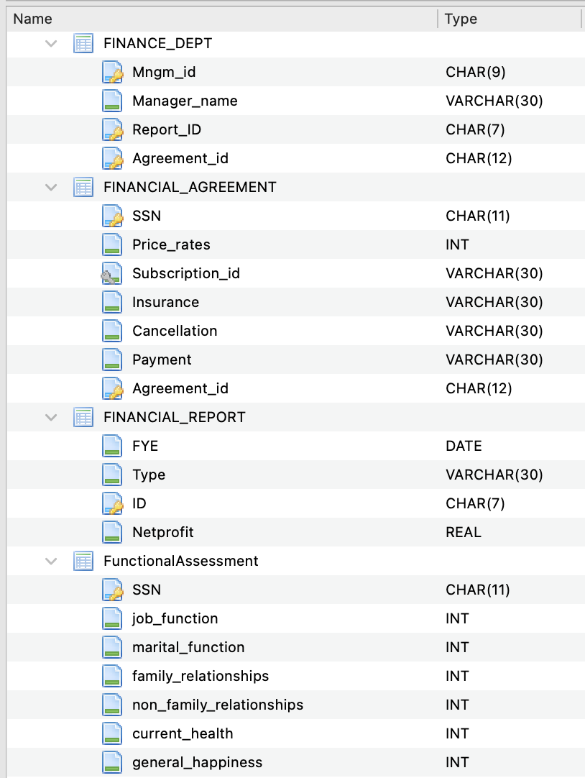
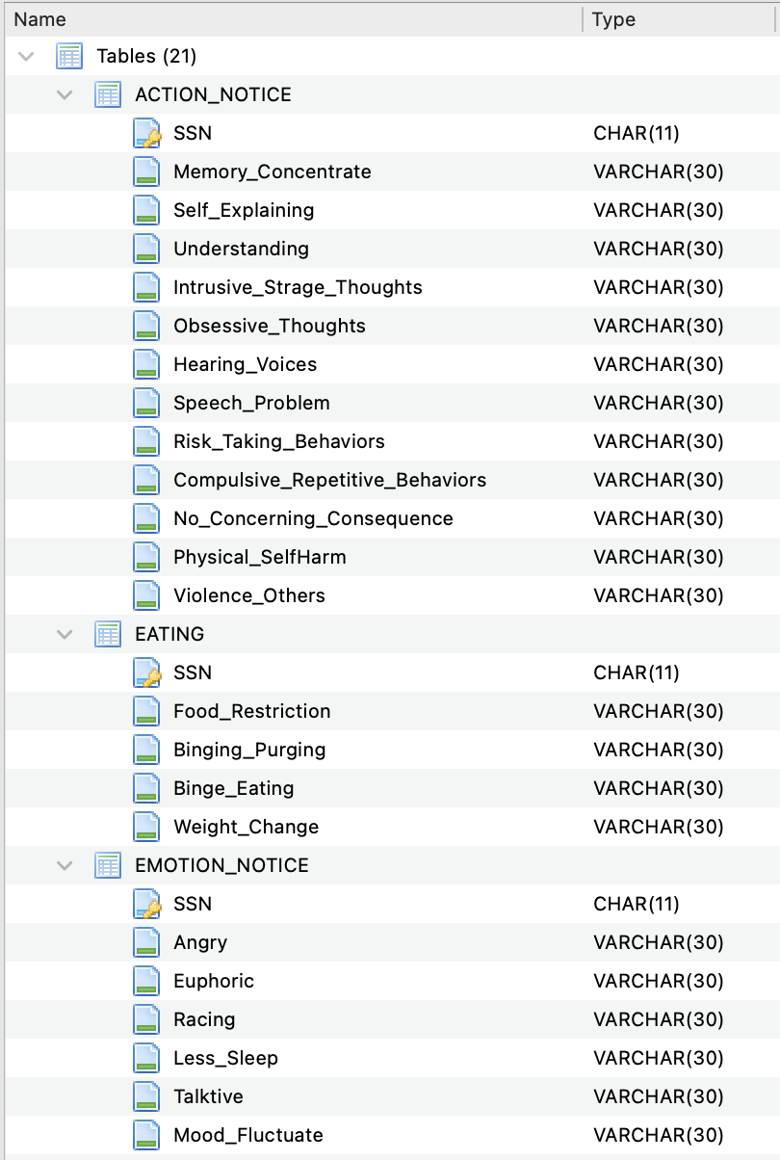
Database Tables:

